**CoBrA (1948–1951)**

CoBrA was a European avant-garde movement active from 1948 to 1951, primarily known for a painterly style of colouristic disfiguration. The name is an acronym of Copenhagen (Co), Brussels (Br) and Amsterdam (A), the home cities of most of the group’s members. CoBrA was founded on 8 November 1948 at the Café de l’Hôtel Notre-Dame, Paris, with the manifesto La Cause Était Entendue (“The Case Was Heard”), signed by the Danish painter Asger Jorn, the Belgian poets Christian Dotremont and Joseph Noiret, and the Dutch painters Karel Appel, Corneille and Constant Nieuwenhuys. Another representative member was the Belgian painter Pierre Alechinsky. In its three-year existence, the group attracted over thirty members, with membership spreading across Europe. Most of the members were painters. Their style was characterised by abstract and improvisational brushstrokes and the use of primary colours, with which they gave rise to anthropomorphic figures that were intended to recall so-called ‘primitive’ art, and the art of the mentally ill and children. Their influences become clear in the pages of the ten issues of the magazine *Cobra* and the four issues of *Le Petit Cobra*; they contain articles about folklore, tattooing, comic strips, and magic, among images of their works.

Like other European avant-gardes that emerged after World War II, CoBrA style was influenced by Fauvism and Expressionism and by modern masters associated with Cubism and Surrealism, such as Pablo Picasso, Paul Klee and Joan Miró. Parallels can be drawn between CoBrA artists and coeval painters associated with *art informelle* and *art brut* like Jean Dubuffet; however, CoBrA emerged out of local traditions. In the 1930s and 1940s, a group of artists in Denmark, who called themselves ‘experimentalists’, were rediscovering prehistoric and medieval Scandinavian art. They formed Linien (*The Line*) and, subsequently, The Høst Group; the ‘primitive’ style of experimentalists like Carl-Henning Pedersen and Egill Jacobsen was crucially influential on the younger generation of Danish artists who formed CoBrA. Jorn, a Høst member and founder of *Helhesten* magazine, was in contact with the Belgian group *Le Surréalism Révolutionnaire*, formed by Dotremont and based on the idea of a possible confluence of Surrealism and Communism, which André Breton had considered unacceptable. Jorn, who was invited to Brussels to talk about folk art and mysticism, exercised a deep influence on the Belgians as well as on Constant, whom he met in Paris and who soon became the leader of the Experimental Group in Holland.

The versatility of CoBrA members brought them to embrace different media, including sculpture, poetry, photography, filmmaking, and publishing, and to organize events where art met with ‘real life’, for example, in collaborative murals and co-housing experiments. Informed by Marxism and the ideas on materialism theorized by French philosopher Gaston Bachelard, CoBrA rejected western culture through looking at art forms untouched by rationalism and capitalism; thus, the group was also interested in medieval art, mysticism, oriental calligraphy, and folk art. CoBrA had artistic as much as social concerns, which clearly emerges from the group’s legacy. Jorn and Constant, in particular, played a pivotal role in the *Internationale Situationniste*, led by French writer and filmmaker Guy Debord, who was moved by the same ambition to change society through art. CoBrA was celebrated for the first time in 1949, while still in progress, in the *International Exhibition of Experimental Art* at the Stedelijk Museum, Amsterdam. In 1950, fifteen monographic booklets were published under the name *La Bibliothèque de Cobra*.

The Cobra Museum of Modern of Art in Amstelveen, The Netherlands, was established in 1995.

**References and further reading**

Alloway, L. (1958), ‘Cobra. Notes in Background to Action: A Series of Six Articles on Post-War Painting’, *Art News and Review*, 4 January 1958, Vol. IX, no. 25: 4

Dotremont, C., Lambert J.C. et al. (1993), *Cobra Revisité: Collection Karel P. van Stuijvenberg*, exh. cat., Liege: Musée d’Art Moderne

Lecombre, S., Besson, C. and Béraud, G. (1982), *Cobra, 1948–1951*, exh. cat., Paris: Musée d’Art Moderne de la Ville

Shield, P., Birtwistle, G. et al. (2003), *Cobra: Copenhagen, Brussels, Amsterdam*, exh. cat., Gateshead: Baltic Museum; Manchester: Art Gallery; Dublin: Irish Museum of Modern Art. Exhibition curated by Hayward Gallery, London

Stokvis, W. (1966), *Cobra 1948-1951*, exh. cat., Rotterdam: Boijmans-van Beuningen Museum

Stokvis, W. (2004), *Cobra: The Last Avant-Garde Movement of the Twentieth Century*, Farnham: Lund Humpries

**Images suggested**

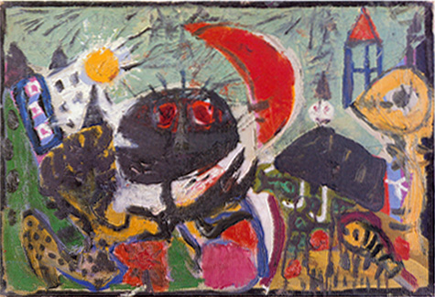

Authors: Asger Jorn, Karel Appel, Constant, Corneille and Erik Nyholm

Title: *On the subject of a painting by Richard Mortensen: Cobra Modification*

Year: 1949

Technique: Oil on canvas

Dimension: 42,5 x 62 cm.

Collection: Nyholm Family Collection, Denmark, on loan to Silkeborg Museum, Denmark [www.silkeborgmuseum.dk](http://www.silkeborgmuseum.dk)

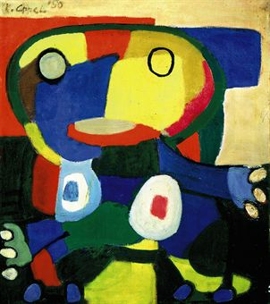

Author: Karel Appel

Title: *Untitled (Le Grand Chef Cobra)*

Year: 1950

Technique: Oil on canvas

Dimension: 98 x 88 cm.

Collection: François Pinault Foundation, Venice, Italy

<http://www.palazzograssi.it/en/françois-pinault>

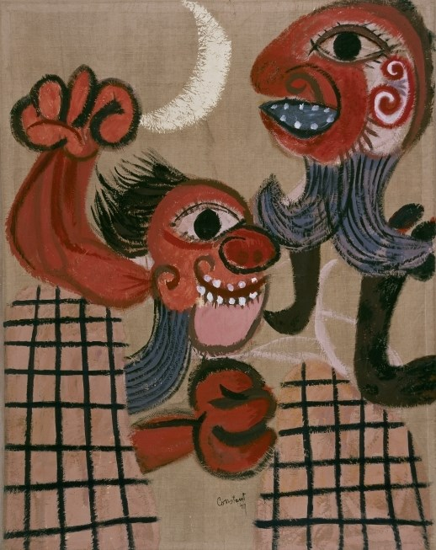

Author: Constant

Title: *Barricade*

Year: 1949

Technique: Oil on canvas

Dimension: unknown

Collection: Stedelijk Museum, Amsterdam

<http://www.stedelijk.nl/en/artwork/2437-barricade>

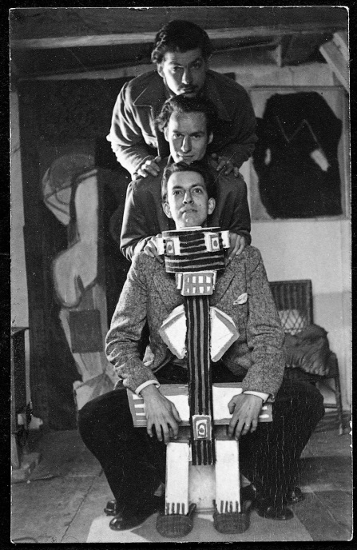

Author: Unknown

Title: Unitled: Appel, Corneille and Constant posing with a ‘totem pole’ by Appel (now lost)

Location and Year: Amsterdam, 1948

Source: <http://p.twimg.com/Az8Zqz5CAAEUx83.jpg:large>

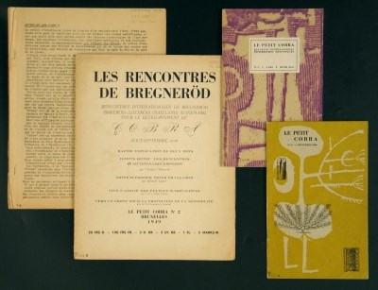

Author: Christian Dotremont

Title: Le Petite Cobra

Year: 1949

Medium: magazine

Source: <http://www.stedelijk.nl/en/artwork/85703-le-petit-cobra>